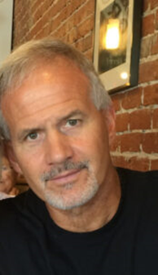 | Mike Iacucci, Board President  Mike retired from a career with the NYS Division of Parole (now part of NYSDOCCS), where he served as the coordinator of reentry services for the western half of the state and served as the Deputy Superintendent of Programs at the Rochester Correctional Facility Work Release program, prior to joining Delphi Rise as the Program Manager for the Supported Forensic Housing program. He has been an adjunct professor in Roberts Wesleyan College’s Department of Criminal Justice. His volunteer activities include his role as former President, and current member, of the Churchville-Chili School Board, and a board member of Grace House Ministries. An active member of his church, he counsels individuals and couples. Mike has a Bachelor’s degree in Criminal Justice and a Master’s degree in Sociology/Human Services.
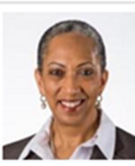 | Dale Sedgwick, Vice President  Dale is an accomplished executive with 30+ years of experience in building high-performing organizations. After retiring from Xerox Corporation as Vice President, Marketing and Communications, she assumed the position of Chief Executive Officer of Hope Initiatives CDC Inc. whose mission is to help restore lives damaged by incarceration, substance abuse and poverty through employment, job training, spiritual guidance, encouragement, and hope. She is a graduate of Hampton University in Hampton, Virginia, where she received a Bachelor of Science degree in mathematics. She also has a Master of Business Administration degree from the Simon School at the University of Rochester, and Certification in Global Account Management from Columbia University in New York and St. Gallen University in Switzerland. She is a Lean Six Sigma Green Belt. Committed to seeing Rochester area residents thrive, Dale has served on several local boards including the Carlson YMCA and Garth Fagan Dance. A committed Christian, she has been an active member of Bethel Christian Fellowship in downtown Rochester, NY for more than twenty years.
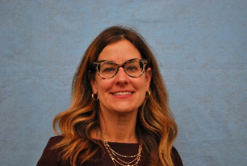 | Cathy Buckert, Treasurer  Cathy retired from the United States Probation Officer, Rochester, NY, in December 2020 after 27 years of service. She was the Program Development Specialist overseeing reentry services, collaborative community partnerships, and evidence-based programming, and was previously the Drug and Alcohol Specialist. She developed and facilitated the Reentry Court Program for eight years. She is certified in Cognitive Behavioral Therapy (NCTI) and provided oversight of the CBT program in addition to facilitating trainings throughout NY. Cathy holds a Master of Education Degree in Rehabilitation Counseling with a Certificate of Advanced Studies (Drug and Alcohol) from Springfield College. Prior to joining the probation staff, Cathy was a drug and alcohol counselor at Park Ridge Chemical Dependency. Cathy is proficient in Motivational Interviewing, trained in Moral Reconation Therapy, certified in Group/Crisis Intervention, Interactive Journaling (Courage to Change) and as a Train-the-Trainer for Trauma Informed Responses in Criminal Justice (SAMHSA). As a certified Offender Workforce Development Specialist (OWDS), Train-the-Trainer/Instructor, she developed, implemented and taught the Ready Set Work Program in WNY and has been an instructor at venues including a federal institution. Cathy is an Adjunct Professor at Roberts Wesleyan College. She is member of the Women’s Initiative Supportive Health (WISH) project. Cathy provides consultation to community sectors agencies utilized her personal and professional experience to assist with embracing a balanced approach to proactively addressing critical barriers to reentry. In 2016, in recognition of her contributions to community corrections, she was awarded the Clair Gsell Excellence in Corrections Award.
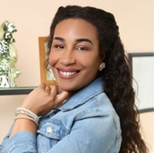 | Khara Grant, Secretary  Khara joins us from Wildflower Consulting. As CEO, she had done business and marketing consulting for various Fortune 500 & 100 firms, like Cisco Software. Most recently, Khara is consulting for Urban League of Rochester, teaching digital Marketing courses to minority/women-owned SMBs in the Rochester area. A native Rochesterian, Khara commutes between her home in Atlanta and her family here in Rochester.
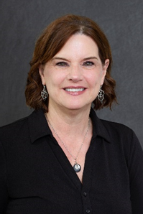 | Leslie Barnes, Board Member  Leslie is currently the Director of Operations/Community Collaboration - Family Access and Connection Team (FACT), and formerly the Executive Director of Hillside’s Community Based and Developmental Opportunities Services. Leslie was the Deputy Chief Probation Officer at the Monroe County Office of Probation until 2016. One of the myriad of responsibilities she held as Deputy Chief was co-chair of the Monroe County Reentry Committee. She has broad knowledge of the Rochester Community and has provided leadership to numerous community and government initiatives.
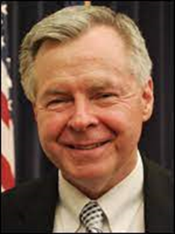 | Bob Burns, Board Member  Bob has served the Monroe County community for decades, as the County's Chief Probation Officer and the Director of Public Safety. Bob was also the Chair the Monroe County Criminal Justice Council and Co-Chair the Public Safety Sector Team. He served as the Chair of the Monroe County Task Force since its inception in 2006, working closely with RAWNY's Executive Director Ann Graham to bring reentry services to our county.
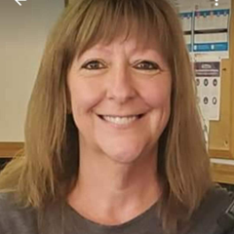 | Lisa Connors, Board Member  Lisa has a bachelor’s degree in Community and Human Services, from SUNY Empire State College, and a certificate in Human Services Leadership from Cornell University School of Industrial and Labor Relations, Human Services Leadership Institute. With over 30 years’ experience working at a the Monroe County Department of Human Services, and served on the Monroe County Reentry Task Force. Lisa brings with her an extensive knowledge of Medicaid, SNAP and Temporary Assistance Program Eligibility Regulations. Lisa has outstanding communication and interpersonal skills with the ability to interact with others easily.
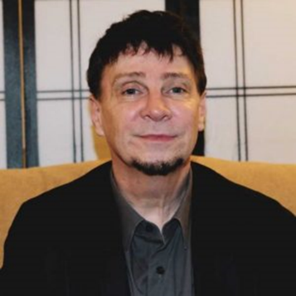 | Craig W. Johnson LMHC, CASAC-G, President Emeritus  Craig is currently the COO of Health Homes and New Initiatives at Huther Doyle Memorial Institute in Rochester. Craig had previously developed a recognized and effective treatment program in the local jail setting, and has served as a consultant to Probation Departments and Mental Health agencies. Prior to his work in corrections, Craig served as the Clinical Director at Park Ridge Chemical Dependency overseeing 7 outpatient programs, and inpatient CD treatment program, two Community Residences and community outreach. He has taught at a number of universities and operates a private practice, Mind Evolution, in Rochester along with serving on a number of boards and community consortia.an experienced and respected trainer on issues related to substance use, mental health and criminal justice involvement. He has taught literally thousands of counselors and impactors about substance use, co-occurring disorders, criminal justice clients and techniques for effective helping strategies.
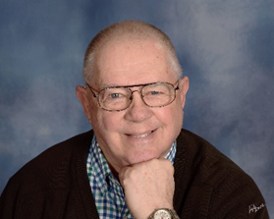 | Dick Laidlaw, Board Member  Dick holds a real estate broker's license, with degrees from Indiana University in business administration and Purdue University with a degree in Industrial Supervision and additional graduate work done in business and Education. Dick experienced 25 years in the hospitality industry in various capacities. Dick was program chair for Hospitality management at Indiana Vocational Technical College and state wide curriculum director. Dick managed 150 students, 8 part time instructors and the apprentice cooks 3 year training program. Dick was the eastern US coordinator for TAPS (a contractor for JTPS) and managed groups in Philadelphia, Chicago, Rochester, Buffalo, McKeesport Pennsylvania(Pittsburg) ,Newark, NJ, Omaha Nebraska, Fayetteville, NC and Tulsa Oklahoma. The job placement rate was 95% with average class size of 30 students . Dick has done work at MCF and MCJ with men, women and youth using CBT with media intervention and aided recall utilizing notebook journaling. Dick initiated Scouts beyond bars for children whose parents are incarcerated as a way to provide structure to the parents and youth affected by incarceration. As a continuation of the jail work, Dick manages PRAM, serves on the advisory board at Industry and the Juvenile Justice Council. Dick is a US Navy veteran.
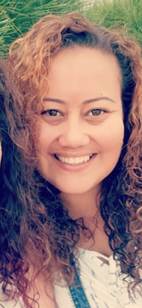 | Brendaliz LopezBoard, Member  Brenda hails from Guanica Puerto Rico. She has been living in the Rochester area since 2013. Brenda is currently a Forensic Housing Case Manager with Spectrum Health and Human Services. She also worked at Delphi Rise in their Forensic Housing, Reentry and Health Homes Care Management programs. Brenda has experience working with high-needs and at-risk populations and believes that it’s important to give back to her community. Brenda has an Associate degree in Tourism, and over 20 years of customer service experience. She has training in Mental Health First Aid, and certifications in Trauma, Resilience and Recovery, as well as in Care Management from the New York State Care Management Coalition. Brenda is bi-lingual and has experience working with individuals from diverse backgrounds. Brenda has one daughter (Reydaliz), who she credits for giving her the motivation and drive to excel in all areas of life
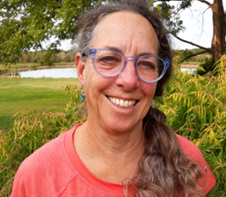 | Marci Muller, Board Member  Marci is currently the Horticulture Team Leader at Cornell Cooperative Extension in Monroe County. She is an adjunct instructor at Finger Lakes Community College, Department of Environmental Conservation & Horticulture. In the past she owned and operated Marstan Landscape, and was the Director of the Rochester Landscape Technicians Program from 2005 to 2012, providing vocational training and GED preparation for men and women in reentry. Marci was also the instructor for Monroe Correctional Facility’s Green House class. She holds a Masters degree from SUNY Empire State College in Business and Policy Studies. Rochester
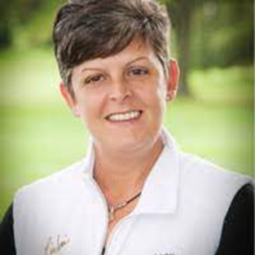 | Tina Paradiso, Board Member  Tina owns and operates Imprintable Solutions, a custom printing and embroidery business where she employs at-risk youth. She also operates the Community Resource Collaborative, whose mission is to uplift young people between the ages of 18 and 24 who are directly and indirectly effected by all forms of violence, including gun violence, domestic violence and trafficking. She is an enthusiastic, authentic and relentless non-conformist who has the ability to see through others’ lens, balancing high expectations with heart to serve others through business.
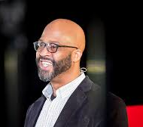 | Dr. Craig A. Waleed, Board Member  Formerly incarcerated citizen, host of the Prison to Promise podcast, educator, author, counselor, and motivational speaker dedicated to excellence in teaching and scholarship and disrupting the community to prison pipeline. Prior to obtaining his doctorate, Craig served as an Addiction Counselor at Catholic Family Center and Senior Case Manager at the Monroe County Reentry Task Force. He also worked as an adjunct professor at SUNY Brockport and Monroe Community College. Craig currently works at the University of North Carolina at Chapel Hill as a postdoctoral fellow in the Social Medicine Department.
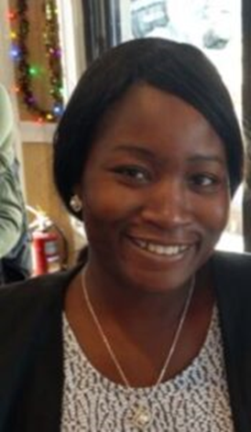 | Kayann Williams, Board Member  Kayann is a native of Jamaica but has called Rochester, NY her home for the past 20 years. Kayann is currently the Program Manager for the Rochester Supportive Housing Program with Spectrum Health & Human Services. She holds a Master’s degree in Educational Policy from the Warner School of Education at the University of Rochester, as well as a Bachelor’s degree in Political Science, with a minor in African and African American Studies, also from the University of Rochester. Kayann has a certification in Behavioral Health – Criminal Justice, as well as a certification in Non-profit Management from St. John Fisher College. Kayann is a certified Offender Workforce Development Specialist (OWDS) who formerly taught the Ready Set Work Program at Delphi Rise. Kayann has experience in the behavioral health field and has also worked in various areas of the educational and legal sectors. She previously worked as an Occupational Specialist at Delphi Rise, and as a Senior AmeriCorps Legal Assistant with LawNY, as well as the National Urban League and the Alliance for Excellent Education. Kayann is an advocate for the dis-enfranchised, she has a passion for helping others, and a desire to influence and enact change.

